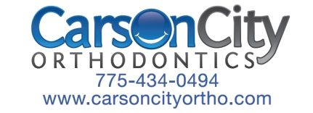
Periodontal Clearance

Date:

Regarding:

Prior to beginning a candidate for a Smile Scholarship and orthodontic treatment, we would like to confirm that we have periodontal/ dental clearance to proceed, and find out if there is any pending treatment that needs to be done by your office. It is my pleasure and an honor to work with you to ensure the very best experience and result of treatment for our mutual patient!

Fax: (775)200-9333 or Email: S4L@CarsonCityOrtho.com

Date of last cleaning: All permanent teeth are present: Pending dental work:
___________________ ⃞ Yes ⃞ No ⃞ Yes ⃞ No

Comments

Doctor's Signature: Date:

Thank you!
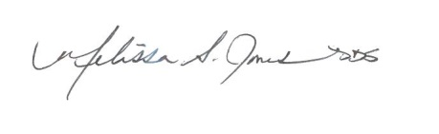

Melissa S. Jones, DDS
(O): 775-267-3600
office@carsoncityortho.com

